6. Multi-Tier Reporting 6-1
Enabling Multi-Tier Reporting 6-1
Data Center Management 6-2
Adding a Data Center 6-2
Building The Data Center File 6-3
Editing Data Center Information 6-3
Deleting a Data Center 6-4
Disassociating Associated Facilities 6-4
exporting Data Center Information 6-5
Importing Data Center Information 6-5
Viewing Log Files 6-7
Converting Database to Multi-Tier Center 6-7
Creating a Multi-tier System From Existing Multiple SCM Data Files 6-8
Importing Data Center Wizard Files 6-10

FILE IS C:\WORK\SCMgr\Documents\new manual\SCMgr-sec6.doc
TEMPLATE IS MANUAL.DOT

This is an information page. Do not include it in the finished manual.

This is an information page. Do not include it in the finished manual.

Multi-Tier Reporting

Multilevel reporting allows for the distribution of data entry responsibility among several locations. This removes the need to transport paper reporting forms from one location to another.

A typical multi-tier system consists of a centrally managed database (the Master DB) and a number of data collection points called Data Centers. The Master DB manages background information (i.e., categories, product definitions, facility types, etc.). Data Centers enter product tracking information for the facilities under their supervision.

Data Centers are created by the Master DB.
 | A multi-tier system can only be created by selecting a role from the Multi-tier Role field on the System Configuration form.

Enabling Multi-Tier Reporting
From an existing database:

- Access the System Configuration form.

If the form has not been completed, see Section 4 – System Configuration for information on completing the System Configuration form.

At the Multi-tier Role field:

- Select Master DB from the field's associated pull-down menu.

 | You must create a Master DB before you can associate Data Centers.
- Click on the System Configuration form's OK button to save the Multi-tier Role and close the form.

You will be returned to the System Configuration submenu.

- Select the Multi-tier Reporting Tools option to proceed to the Multi-tier Reporting Tools submenu.

Data Center Management
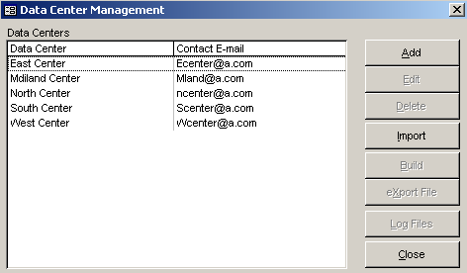
Figure 6-1 – Data Center Management formThe Data Centers option lets you associated data centers with the current Master DB.

- Click on the Data Center option.

The Data Center Management form appears similar to Figure 6-1.

Adding a Data Center
Data Centers are added with the Add button.

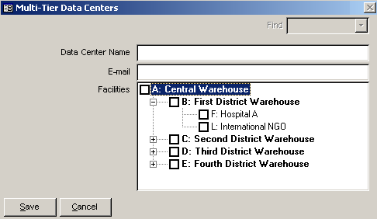
- Figure 6-2 – Multi-tier Data Center formClick on the Add button.

The Multi-tier Data Centers form (Figure 6-2) is displayed so you can enter basic information about Data Centers.

The Data Center Name field lets you identify the Data Center.

- Click in the Data Center Name field and type the Data Center's name.

The E-mail field lets you indicate the Data Center's email address.

- Click in the E-mail field and enter the Data Center's email address.

The Facilities area shows the supply chain of facilities in the current system. Entries listed in this area are added through the Add Facilities operation detailed in Section 5 of this manual.

If the facility you want to associate is not listed, you will have to add it. See Adding Facilities in Section 5 of this manual for information on adding facilities.

To associate a facility with a data center:

- Click in the box corresponding to the facility you want to associate.
 | Facilities displayed in Red are already managed by another data center. Each facility can only be a part of one data center.

After you select the facilities you want to associate:

- Click on the Save button to save you selection(s).

Building The Data Center File
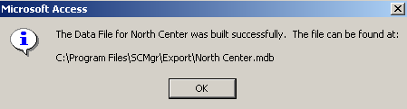
Figure 6-3 – Data file completion messageAfter you define a data center, you will need to build the data center record. Building the data center record simply means creating a database file for a newly defined data center. This is necessary to import and export data. Creating the data center record is accomplished as follows:

- Select the data center you need to build a data center record for.

- Click on the Build button.

The system builds the file and displays a message box similar to Figure 6-3.

Editing Data Center Information
The data of an existing data center can be edited as follows:

From the System Maintenance menu:

- Select the Multi-Tier Reporting Tools option, and select the Data Centers option from the Multi-Tier Reporting Tools menu.

The Data Center Management form (Figure 6-1, page 2) is displayed.

- Select the data center you want to edit.

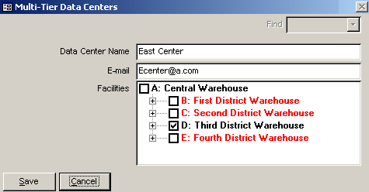
Figure 6-4 – Sample Multi-Tier Data Centers formWhen you select a data center, the Edit button becomes active.

- Click on the Edit button to display the Multi-Tier Data Centers form.

The Multi-Tier Data Centers form appears similar to Figure 6-4.

Facilities associated with the selected data center are marked with a checkmark (✓) as shown in Figure 6-4. Facilities in red are associated with other data centers. You can associate any of these with the current data center.

- Make the necessary changes and click the Save button.

Deleting a Data Center
A data can be deleted as follows:

From the System Maintenance menu:

- Select the Multi-Tier Reporting Tools option to display the Multi-Tier Reporting Tools menu.

- Select the Data Centers option.

The Data Center Management form (Figure 6-1, page 2) is displayed.

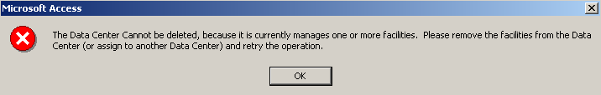
Figure 6-5 – Sample error messageBefore you can delete a data center, you must first disassociate any and all facilities associated with the data center selected for deletion. If you try to delete a data center with associated facilities, an error message similar to the sample below is displayed.

Disassociating Associated Facilities
To disassociate facilities from a data center selected for deletion:

Click on the Edit button and search for any and all facilities associated with the data center selected for deletion.
 | All facilities associated with the selected data center will be marked with a checkmark (✓).

- Click on every checked facility to remove the checkmark (✓) to disassociated the facility.

- Click on the Save button to save your changes.

- Now, with the data center chosen for deletion still highlighted, click on the Delete button.

A confirmation message is displayed asking if you are sure that you want to delete the selected data center.

- Click on the Yes button to delete the selected data center.

The selected data center is deleted from the Data Center Management form.

exporting Data Center Information
Data center data can be exported to update the remote data centers background data. The data compiled for export consists of background table changes that can be sent to a managing data center. To create an export file:

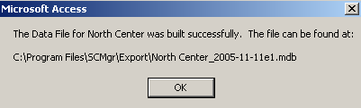
- Figure 6-6 – Export file completion messageSelect the data center you want to create an export file for.

- Click on the Export File button.

The system will create the export file and display a message box similar to Figure 6-6.

Importing Data Center Information
This feature is used to create (or recreate) a data center in a master database file from a wizard file (.wiz) as created from a lower-level data center.

Data from subordinate data centers can be pulled into a managing data center for incorporation into a master database. This operation accomplishes three (3) tasks:
- It allows for the import of multi-tier data files
- It performs a validation check on files selected for import
- It ensures that selected files are of a valid type for the current data center
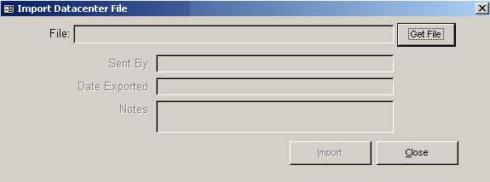
Figure 6-7 – Datacenter Import form
To import a data file:

- Click on the Import button.

The Datacenter Import form is displayed Figure 6-7.

The File field identifies the file to be imported. This field has an associated Get File button that helps you locate the file you need to import.

- Click on the Get File button.

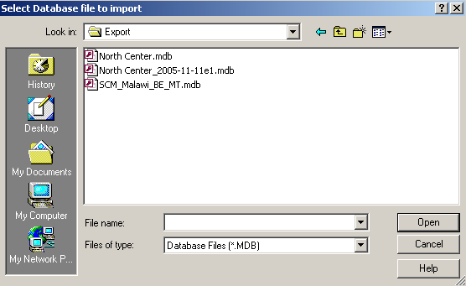
Figure 6-8 – Select Database File to Import windowThe Select Database File to Import window if displayed. This is a standard Windows file selection window that operates like any other Windows file selection window.

- Locate and select the data file you need to import.

- Click on the Open button.

Basic information about the selected file is displayed on the Import Datacenter File form as shown in sample Figure 6-8.

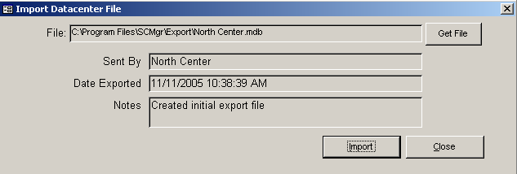
Figure 6-9 – Datacenter File form
 | You cannot edit any fields associated with the Import Datacenter form.
- Click on the Import button to import the data associated with the selected data center.

The data associated with the selected data center is imported.

- Repeat steps 1 through 5 to import data from additional data centers.

When you are finished importing data:

- Click on the Close button to close the import form.

Viewing Log Files
The Log Files button lets you view a data center's import and export history. To view a log file:

- Select the data center with the import/export history you want to create a log for.

- Click on the Log Files button.

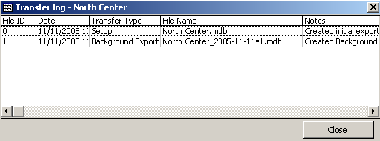
Figure 6-10 – Sample import/export log fileThe import/export history of the selected data center is displayed similar to sample Figure 6-10.

- Click on the Close button to close the window.

- Click on the Close button on the Data Center Management form to close the form.

Converting Database to Multi-Tier Center
This procedure helps you take an existing flat data system and turn it into a multi-tier system.

- Access the System Configuration form.

At the Multi-tier Role field:

- Select Master DB from the field's associated pull-down menu.

 | You must create a Master DB before you can associate Data Centers.
- Click on the System Configuration form's OK button to save the Multi-tier Role and close the form.

You will be returned to the System Configuration submenu.

- Select the Multi-tier Reporting Tools option to proceed to the Multi-tier Reporting Tools submenu.

- Select the Data Centers option to display the Data Center Management form (Figure 6-1 on page 2).

Data Centers are added with the Add button.

- Click on the Add button.

The Multi-tier Data Centers form (Figure 6-2 on page 3) is displayed so you can enter basic information about Data Centers.

- Enter the data center's name and email address.

The Facilities area shows the facility types associated with the current system. Entries listed in this area are added through the Add Facility Types operation detailed in Section 5 of this manual.

To associate a facility type with a data center:

- Click in the box corresponding to the facility type you want to associate.
 | Facilities displayed in Red are already managed by another data center. Each facility can only be a part of one data center.

After you select the facilities you want to associate:

- Click on the Save button to save you selection(s).
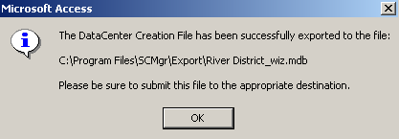
Figure 6-11 – Data center file confirmation message Delete this image and use the one below.
- Select the new Datacenter from the data center list and click build to produce the starter .mdb for the Datacenter.

A confirmation message similar to the sample in Figure 6-11 is displayed to let you know that the data center file has been created.

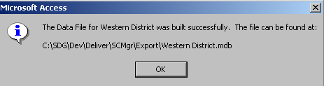
Use this image instead.

- Click on the OK button.
- to use the new file at the Datacenters location, copy the file to the \Data subfolder and link to the file using the linked tables form.

Creating a Multi-tier System From Existing Multiple SCM Data Files
From an existing database,

- Click on the System Maintenance option of the main menu.

- Click on the System Configuration option of the System Maintenance menu.

- Click on the Multi-Tier Reporting Tools option.

- Click on the Convert Database to Multi-Tier Data Center option.

Figure 6-12 – Multi-tier Data Center formThe Multi-tier Data Centers form (Figure 6-12) is displayed so you can enter basic information about Data Centers.

The Data Center Name field lets you identify the Data Center.

- Click in the Data Center Name field and type the Data Center's name.

The E-mail field lets you indicate the Data Center's email address.

- Click in the E-mail field and enter the Data Center's email address.

The Facilities area shows the supply chain of facilities in the current system. Entries listed in this area are added through the Add Facilities operation detailed in Section 5 of this manual.

If the facility you want to associate is not listed, you will have to add it. See Adding Facilities in Section 5 of this manual for information on adding facility types.

To associate a facility with a data center:

- Click in the box corresponding to the facility you want to associate.
 | Facilities displayed in Red are already managed by another data center. Each facility can only be a part of one data center.

After you select the facilities you want to associate:
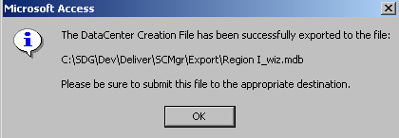
Figure 6-13 – Wiz file creation message
- Click on the Save button to save you selection(s).

A data center export file will be created and the current database will become the selected data center. A message window similar to the sample in Figure 6-13 is displayed when this process is complete.

- Click on the OK button to close the message window.

The database is now a multi-tier data center.

Importing Data Center Wizard Files
After you create the data center files (as explained in Converting Database to Multi-Tier Center beginning on page 10), you can import the files into the newly created multi-tier data center as follows:

From the System Maintenance menu,

- Click on the System Maintenance option then click on the Multi-tier Reporting Tools option in the Configuration menu.

- Click on the Data Center option.

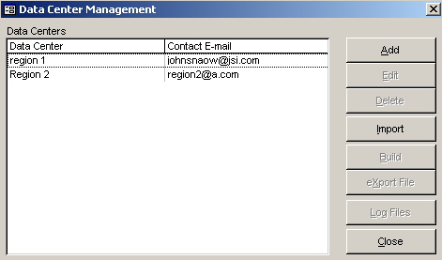
Figure 6-14 – Sample Data Center Management formThe Data Center Management form is displayed similar to Figure 6-14. This form shows you the data centers that have been identified as multi-tier data centers.

- Click on the data center you want to associate the newly created data center wizard file with.

- Click on the Import button and select the data center wizard file you created.
 | Data center wizard files are identified by having wiz associated with their name (i.e., datacenter-1_wiz.mdb, datacenter-2_wiz.mdb, etc.).

After you select the wizard file to created,

- Click on the Import button.

The data associated with the wizard file is imported and compared to any data that may exist in the multi-tier data center. If there are nay inconsistencies in the data, the Adjustment Record Changed window, similar to the sample in Figure 6-15 on the following page, is displayed.

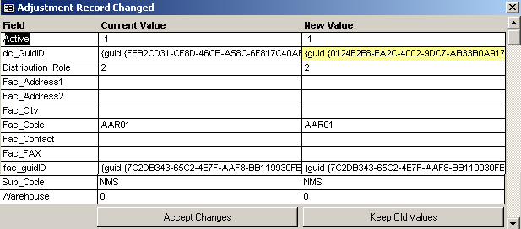
Figure 6-15 – Sample Adjustment Record Changed window
You have the option of accepting the new value or keeping the current value in the multi-tier database.

 | Values that do not match are highlighted in yellow as shown in sample Figure 6-15 on page 15.
- Click on the Accept Changes button to accept the new, imported values.

- Or, click on the Keep Old Values button to retain the current database values

In either case, you will have to repeat your selection for each questioned value.

During the import operation, a message box similar to the sample in Figure 6-16 may be displayed.
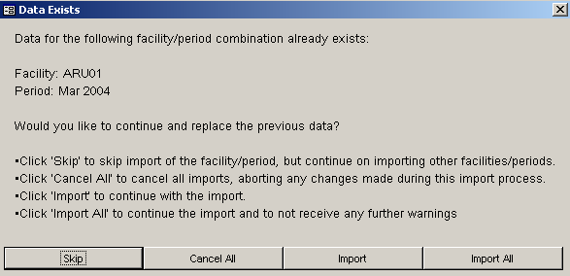
Figure 6-16 – Data Exists message window

This message box appears only if data for a particular facility/period combination already exists. You will have the following options available to you:
- The Skip button:
Do not import data of a particular facility/data period. Continues to next facility/data period.
- The Cancel All button:
Cancel the import and undo the imported data files product tracking data records.
- The Import button:
Continues the import of a particular record, and asks again if another conflict is found.
- The Import All button:
Continues with import, and will not ask if another conflict arises.

- Click on the option button that best suits your situation.

After you complete the import operation, a message window similar to sample Figure 6-17 is displayed to let you know that the import operation was successfully completed.
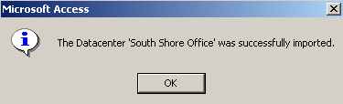
Figure 6-17 – Successful import completion message

- Click on the OK button to close the message window.

- Repeat the import operation as many times as needed.

When you finish importing the wizard files you need,

Click on the Close button on the Import Datacenter File form to return to the Data Center Management form.

Click on the Close button on the Data Center Management form to return to the Multi-tier Reporting Tools menu.

